Charles Carlson

Wade McTaggart

**Purpose of the Database**

The purpose of our database is to inform locals and visitors to Chicago of dangerous areas by displaying that information on a map. Our application will be a prototype, but if we had access to data coming in in real-time, flat files would be impossible to work with as they would have to be continuously regenerated. Users of our application will be able to visualize crime in near them or around popular attractions within Chicago. The database is necessary for storing crime data in the Chicago area and the application will query our remote database to display data. By creating a visual representation of the data, any user will be able to answer questions such as: “Which ward is the most dangerous?”, “What areas become more dangerous at night, and vise versa with day?”, “What representative is responsible for the most crime-ridden ward?”.

On wards

While the majority of the database is populated from the Chicago Crime dataset the geometric boundaries for wards comes from shapefiles. These shapefiles are accurate for the year 2015, so our crime dataset will only contain crimes that took place in 2015. A shapefile is sufficient for this purpose as the geometry for a ward is static for a given year and not subject to change.

**Requirement specification**

The purpose of this geodatabase is to make it easy for people to see where crime has happened in Chicago and show hot spots and trends. The geodatabase will include tables describing the various types of crimes, blocks, and wards. The geodatabase will feature relationships between crimes and crime locations that will allow us to uniquely identify each crime that takes place in the Chicago. This relationship will also include spatial data in the form of latitude and longitude allowing to exactly pinpoint the location of a crime using the Google Maps API.

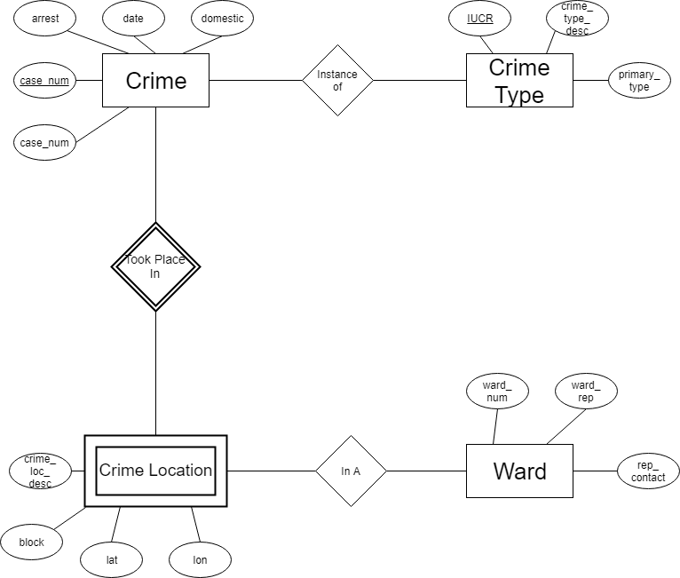

*Identify constraints in your database tables/layers here.*

**Requirement specification**

The data is taken from Chicago Crime Dataset from the kaggle datasets from https://www.kaggle.com/currie32/crimes-in-chicago. The data will be downloaded locally and then exported to a PostgreSQL database hosted in AWS (free account). The app will be a cross-platform mobile application written in React Native, though emphasis will be placed on the iOS version for the sake of time. The application will make queries to our database in order to display crime data on our map.